SidCup Website

1. For a black wash over the website

Don’t create “main” div ….create navbar and then the video in the background.

Then make a “main” div inside which add another div to add the contents of the page

#main{

    position: relative; // to bring the black bg color on the surface

    background-color: rgba(0, 0, 0, 0.338); // create a black wash on page

}

#page1{

    width: 100%;

    height: 100vh;

}

1. To bring the contents of the page to center,

Put everything, the parent and the child to position: relative

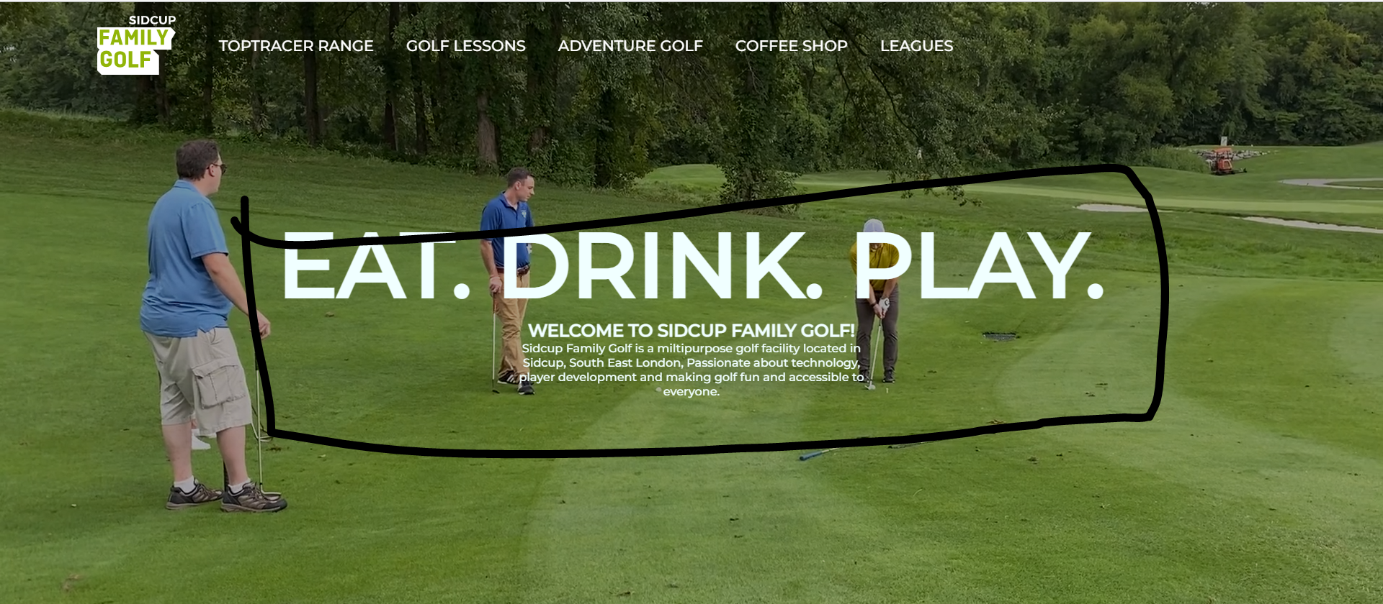

#page1{

    width: 100%;

    height: 100vh;

    display: flex;

    flex-direction: column;

    align-items: center;

    justify-content: center;

    color: azure;

    /\* position: absolute;

    top: 35%;

    left: 15%; \*/

    position: relative;

}

To put the elements on center

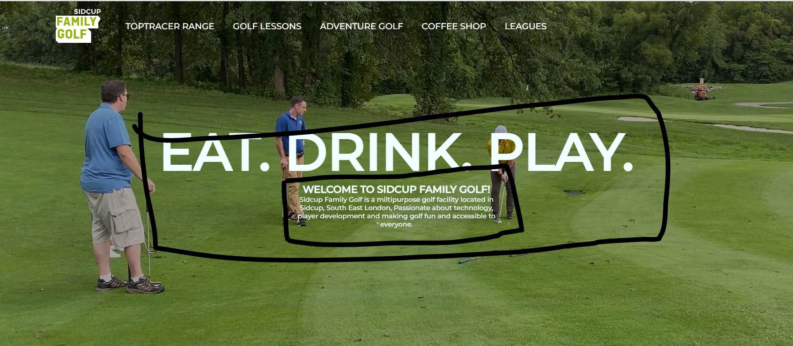

#page1 h4{

    text-transform: uppercase;

    font-weight: 800;

    width: 50%;

    text-align: center;

    margin-bottom: 10px;

}

#page1 h6{

    font-weight: 500;

    width: 26.5%;

    text-align: center;

Adjust width to center the elements and text-align : center

1. After – Before Effect on Text



#page1 h1{

    text-transform: uppercase;

    font-size: 95px;

    font-weight: 900;

    position: relative; // apply to parent

}

#page1 h1::before{

    content: "eat. drink. play."; //mandatory

    position: absolute;

    color: black;

    top: -5px; //apply on the parent texts

    left: -5px;

    -webkit-text-stroke: 2px #95C11E;

    z-index: -1;

}